Indus River Valley Civilization
Part One: Overview ___/10
- Circle where on the world map this civilization was located. __/1
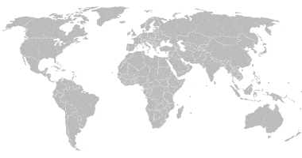
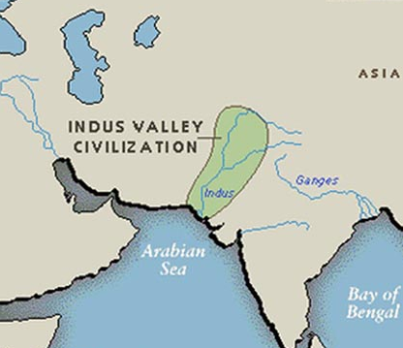
- Make a dot for, and label, the cities Harappa and Mohenjo-Daro ___/2

- From which mountain range does the Indus begin and to which sea does it flow into? __/1
- Was this civilization peaceful or violent? Find two supporting facts that it was peaceful and one supporting fact that it was violent. ___/3

Peaceful | Violent

- Below provide a quick sketch for what an Indus city street may have looked like. Include walls, street width, and drains. Label each and include any notes which may help give your picture clearer meaning. ___/4

Part Two: Everyday Indus Life ___/15
- Why did people spend lots of time outside? What did their outdoor spaces look like? What were they used for? ___/3

- What kind of foods did people here eat? How do we know what they ate? ___/2

- What did people do for entertainment? What is a game piece the Indus civilization invented that you probably have in your house today? ___/2

- Which of the four common jobs found in the Indus River Valley civilization would you want to do and why? __/2

- Did people of the Indus Valley use money or trade goods? ___/1

- What are seals? ___/2

- Design your own seal. ____/3

