Social Studies 9

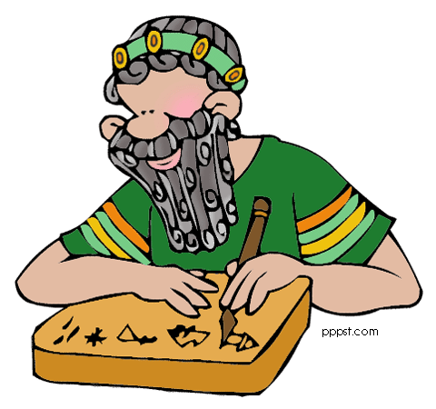
Assessment & Evaluation
Throughout the year you will be assessed on multiple outcomes found in the S. ST. 9 curriculum. These outcomes look at how you comprehend and respond to materials studied, your composition and creativity in presenting your knowledge, and finally, how you assess and reflect upon your own work, attitude, and time spent in class. Assessment for all outcomes will be done on a 4 point scale. These outcomes will be assessed in two different ways:

Formative (On-going throughout the year to see how you are doing, what you are successful at, and what needs more attention). “Practice”

Summative (Done at different times throughout the year to see if you have “mastered” the skill being assessed). “Game Time”

You will be required to write a unit exams and a final exam in June. Your final mark will be cumulative, based on assessments done throughout the year. This mark is based on ALL work covered in class, meaning all work must be completed and handed in.

The Roots of Society

Grade 9 students will explore worldviews of past societies and connections between the past and the present. Students will consider how worldviews are shaped and how they are expressed by people living in particular times and places. They will examine issues related to contact between societies with differing worldviews. Students will explore diverse sources of historical information, including oral histories, images, literature, and the arts. Through this inquiry into past societies, students will reflect upon their own worldviews, assess the influences of the past on the present, and further develop their historical consciousness. Students will explore at least one historical indigenous society of North America, as well as Mesopotamia or Ancient Egypt; Ancient Greece or Rome; Aztec, Incan, or Mayan civilizations; Medieval Europe or Renaissance Europe; Ancient China or Japan.

Social Studies 9 Class Procedures & Expectations

The following is a list of rules and attitudes that I believe are key to your success in this class. For a full list of students’ rights and responsibilities and school rules, please see your Student Handbook.

- “The Golden Rule” – Do unto others as you would have them do unto you.
  - Strive to uphold this rule at all times. If you wish to be treated with respect, then treat others with respect.
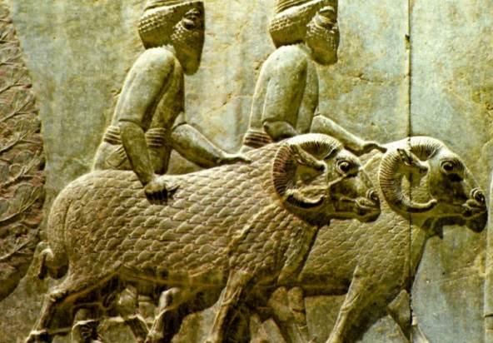
- Students are expected to be respectful to EVERYONE (students, staff, community, guests) in Warman High School.
- Students are expected to contribute to a safe and positive learning environment that is welcoming of all students.
- Come to class regularly, on time, and ready to learn. Bring all the materials you will need for that day. Come with a positive attitude and a willingness to try new things.
- “Mr. Rowland’s Finishing School” - Outside my door / Strong minds and bodies

Exam Rules
- No talking. If you choose to speak out of turn, you risk losing your exam and receiving a mark of zero. If you have a question, you may raise your hand, wait until I come to your desk and ask the question to me in a quiet voice.
- No cheating. Cheating receives an automatic removal of your exam and a phone call to your parents.
- Once the exam has begun, you may not leave your seat or the room.
- Have all materials necessary to write your exam at your desk.
- Books, papers, pencil cases, etc., will be required to be closed and placed on the floor.

Assignment Expectations
- Papers are to be neat, well-organized, and have a proper title page.
- Use blue or black pen or type assignments.
- All hand-in work is to be double-spaced unless otherwise indicated. Typed assignments must also be 12 font Times New Roman.
- Students are to use proper grammar, spelling and punctuation at ALL times (writing and speaking).
- Assignments are to be handed in at the beginning of class on the date specified.
- Major projects and essays are due before 3:15 p.m. on the date specified.

Due Dates

Due dates for assignments and projects will be posted in the classroom, and it is the student’s responsibility to ask questions and seek help if unsure. It is expected that students will hand assignments in on time unless they have arranged an alternative due date in advance for a valid reason.

Work that is late will be recorded as NHI (Not Handed In) in PowerSchool (NHI is a mark of 0 until work is received). Students are to inform teacher for reason assignment is late and hand in the assignment upon an agreed date. Parents will also be notified at this time. If the second due date is passed, administration will be informed and students will be required to hand in the assignment at a due date as agreed upon by all parties. If this is not successful, students will have then earned a “ZERO” and will be recorded as such in PowerSchool.

We will be examining these concepts and civilizations:

- Archeology / Society / Historical Terminology
- Mesopotamia
- Egypt
- Greece
- Rome
- Maya, Aztec, Inca
- Middle Ages
- Renaissance
- First Nations

These concepts and civilizations will be studied in four different units:
Unit 1 – Interactions and Interdependence of Nations – Sept/Oct
- Explain what constitutes a society
- Compare the factors that shape worldviews in a society, including time and place, culture, language, religion, and education
- Analyze the ways a worldview is expressed in the daily life of a society
- Determine the influence of worldview on the choices, decisions, and interactions in a society
Unit 2 – Dynamic Relationships – Oct/Nov
- Examine the challenges involved in obtaining information about societies of the past
- Synthesize the significance of key historical events in societies studied
- Assess the relationship of the natural environment in the development of a society
- Determine the influence of societies of the past on contemporary life in Canada.
Unit 3 - Power and Authority – Nov/Dec
- Examine concepts of power and authority in the governance of the societies studied.
- Analyze the impact of empire-building and territorial expansion on indigenous populations and other groups in the societies studied.
- Investigate the roles and responsibilities of members of the societies studied and those of citizens in contemporary Canada.

Unit 4 - Resources and Wealth – Dec/Jan
- Compare differing perspectives regarding the acquisition and distribution of resources and wealth in the societies studied.
- Appraise the significance of trade and transportation in the development of the societies studied.
- Determine the influence of technologies of past societies studied on contemporary society.

Most of what we cover in class is posted on my Weebly page:

http://rowlandsocialstudies9.weebly.com/

password: warman

