The Sumerian Worldview

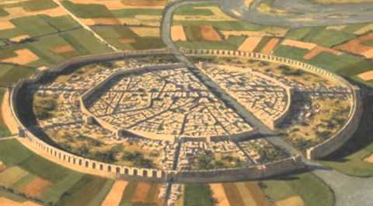
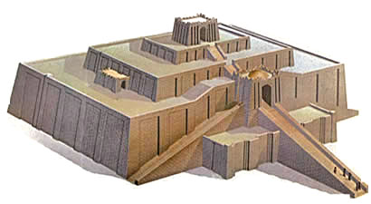
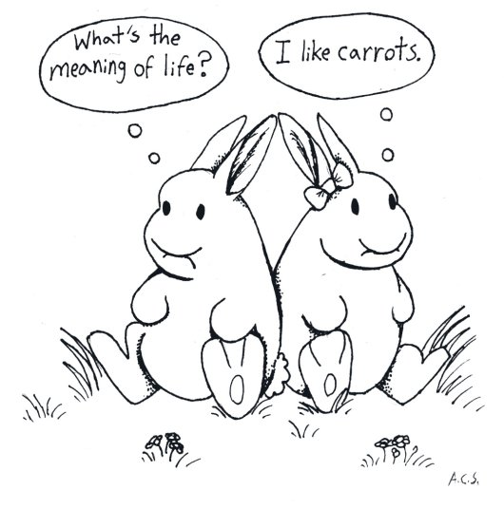
The Sumerian civilization was comprised of some twenty temple-centred city-states that arose during the 4th millennium BCE in the fertile plain between the Tigris and Euphrates rivers south of present-day Baghdad. Although increasingly linked over the centuries by trade that took place along the canals and rivers of southern Mesopotamia, each city was independently ruled by a priest-king and council of elders. By the end of the 4th millennium, several had populations exceeding 10,000, and the city of Uruk became the first in the world to surpass 50,000 inhabitants. Together they gave birth to the wheel, written language, mathematics (including geometry and algebra), astronomy, kiln-fired pottery, large-scale irrigation, monumental architecture, urban planning, the first codified legal system, epic literature, and the first schools that flourished under the auspices of the city-state’s primary temple.
These city-states, which had evolved from earlier Neolithic villages, continued to evolve over the 2000 years of Sumerian history. Each was surrounded by a belt of agricultural land that contained many small hamlets connected by a network of roads, canals, and irrigation ditches. Typically situated on a major waterway, each city was linked by a main canal to its own harbour. Divided into commercial, civic, and residential spaces, the residential areas were further divided according to the occupants’ work specialties and social status. Houses – about 90 square metres or 950 square feet in size – were designed so that rooms opened only onto a private inner courtyard, thereby maintaining a clear separation of public and private spaces.
At the centre of each city was a high temple around which the city had grown, and which itself had grown from a small one-room structure in Neolithic times into a successively larger and more elaborate complex that might occupy several acres. As cathedrals today give architectural expression to key components of the Christian worldview, with their high altars, cross-shaped nave and transepts, and steeples pointing heavenward, so these ancient temples gave expression to the Sumerian cosmology. The world was seen as a disc of land surrounded by a salt-water ocean which in turn floated on a primeval sea of fresh water. Above was a giant dome-shaped firmament within which the fixed motions of the heavenly bodies regulated time. Uniting this three-layered cosmos was the Cosmic Mountain or axis mundi, represented by the temple which was home to the patron god of the city and the place of meeting between gods and men. Doors along the long axis of the rectangular temple were entry points for the gods; doors along the short axis provided entry points for men. At the intersection of the two axes, at the centre of the temple, was a table for receiving offerings. Here one could turn 90 degrees to face a statue of the city’s patron god at the far end of the central hall.
The temple was initially built on a raised terrace of rammed earth, later on a higher platform of adobe brick, and still later on a much higher stepped pyramid or ziggurat (which may have inspired the Biblical story of the Tower of Babel). This raised platform represented the primordial land that, in creation, had emerged from the underlying sea. On it the temple was oriented such that its four corners pointed in the cardinal directions of the compass, from whence four rivers flowed from the Cosmic Mountain to water the earth. The roof of the temple served as the observatory from which priestly astronomers kept track of the time. And, as the temple grew ever larger during the Dynastic Period (2900 – 2270 BCE), it became as well a storage and distribution centre for surplus food and the primary residence of the priests.
Not far away, the priestly governor (ensi) or king (lugal), together with his council of elders, kept court at the palace. Like the temple, it had grown during the Dynastic Period from modest beginnings into what became known as “the Big House”. At the same time, and not coincidentally, the cities themselves became walled. During earlier centuries, there had been no military class, little or no armed conflict, and no reason for a city to be walled. But from the start of the 3rd millennium BCE, the growing power of the temple-palace alliance brought with it increasing violence. Cities became walled, undefended villages disappeared, rulers vied with one another for power, and cities began to engage in siege warfare with each other as they sought to expand their territories. The city of Lagash annexed almost all of Sumer and introduced the use of terror as a means of reducing other city-states to tribute. The first historically recorded war took place between the cities of Lagash and Umma c. 2525 BCE. Lagash was later conquered by the priest-king of Umma who went on to claim an empire stretching from the Persian Gulf to the Mediterranean. He in turn was overthrown by Sargon of Akkad who absorbed all of Sumer and proceeded to establish the far-flung Akkadian Empire. Violence was now institutionalised. What began as a cooperative constellation of city-states had, in just a few centuries, surrendered to the imperial ambitions of one dynasty after another.
Accompanying this escalating violence was a worldview that supported it. While the relatively benign presence of the Great Mother was still a focus of Sumerian worship, the nature spirits of the earlier Paleolithic and Neolithic eras had now become more godlike forces of nature. By the 4th millennium BCE, they had morphed into individual deities within a pantheon of gods and goddesses. Although still associated with the forces of nature and immensely powerful, they were now human in form, had human qualities and foibles, and among themselves were unequal in status. Some of them became patron deities of particular cities that they ruled through their earthly representative – the priest-king of that city. It followed that the increasingly frequent and violent power struggles between cities should be seen as a contest between their associated deities.
Nammu, goddess of the primeval sea, may have been the earliest deity. Sometimes described as the mother of all gods, she gave birth to heaven and earth – specifically to her first-born, An, the god of heaven, and then to Ki (later known as Ninhursag), the goddess of earth. From their union in turn cameEnlil, god of the air, who separated heaven and earth. An carried off heaven, while Enlil carried off his mother, earth, and with her proceeded to create man and the entire world of plants and animals. An ,the first male sky-god to appear in human history, was seriously concerned with power and served as supreme ruler and alpha-male of the pantheon, as well as the patron god of the city of Uruk – at least until Uruk was defeated by the city of Nippur, whereupon its own patron god, Enlil, replaced him as the supreme object of worship.
Each of these main players had specific functions. An was the power that gave being to all nature.Ninhursag governed wildlife and gave birth to kings. Enlil was god of the winds and of crop-growing weather. Of lesser rank, but significant nonetheless, were the sun god (Utu), the moon goddess (Nanna), and a host of male sky-gods who belonged to a kind of heavenly club known as the Anuna. There were deities for almost everything – for the other celestial bodies, for geographical features such as mountains and steppes, for important tools such as brick-moulds and ploughs, and for each of the crafts, as well as very personal gods who were served by individuals and households.
This pantheon of deities answered life’s most basic questions, How did we and the universe come into being? What is our place in the larger scheme of things? What drives the forces of nature, and what can we do to control them? It was the gods who brought all things into being and created humans from clay in order to serve them. “Worship your god every day,” reads the Babylonian Counsels of Wisdom, “with prayer and sacrifice, accompanied by incense. Present your free-will offering to your god, for this is proper. Offer him prayer, supplication, and prostration daily, and you will get your reward. Then you will have full communion with your god. Reverence begets favour; sacrifice prolongs life; and prayer atones for guilt.” Beyond the demand that we serve them, however, the Sumerian gods seem not to have specified any code of behaviour such as we find later in the Jewish Torah. Nor was behaviour motivated by any promise of heavenly reward or eternal damnation. Men and women were on their own to decide issues of right and wrong, good and evil. And regardless of how they had lived, all were destined to descend after death into a gloomy Underworld where they could expect to spend eternity as a ghost.
The Underworld was ruled, at least from 2400 BCE, by Gilgamesh. Earlier in that millennium he had been king of the city of Uruk, around whom such legends had grown that he was later elevated to the status of a god and king of the Underworld. The myths and legends surrounding him are related in The Epic of Gilgamesh, told and retold by the Sumerians, and later by the Assyrians and Babylonians, over at least two thousand years. Although details of the story differ from one version to another, the main theme – coming to terms with the fact of our mortality – remains the same. Knowing that all men must die, a youthful and irrepressible Gilgamesh and his companion Enkidu set out on a journey to accomplish a heroic deed (slay a mythical monster) and thereby achieve a kind of immortality. In the process, however, they insult the Great Mother who decrees Enkidu’s death and reduces Gilgamesh to resignation regarding his own mortality. Henceforth, because of his heroism in confronting death, he is made ruler of the Underworld and his blessing is invoked in Sumerian burial rites.
The same Gilgamesh narrative includes the story of the Flood and is almost certainly the source of the later Biblical account. According to the Sumerian version, the gods decided on a whim to destroy humankind with a flood. But Enki, patron god of the city of Eridu, was less than happy with the decision and told a man named Utnapishtim to build a very large boat in which to preserve himself, his family, and a host of animals. After six days and nights of riding out the flood, the boat grounded on Mount Nisir (in modern-day Iraq). After another seven days, three birds were released in succession. When the third one did not return, Utnapishtim knew the flood was over.
Alongside the growing pantheon of gods and goddesses, the Great Mother retained a central role in Sumerian mythology – worshipped as the goddess Inanna (“queen of heaven”) until the beginning of the 1st millennium BCE, and thereafter as the Babylonian goddess Ishtar. An epic poem, The Exaltation of Inanna, described her as all-powerful and reigning in heaven. Associated with the life-giving powers of fertility and abundance, and hence not as war-mongering as many of her male counterparts, she was still far from domesticated. Sexual attraction is aroused in her presence, and she herself is described as sexually aggressive. In The Epic of Gilgamesh, her sexuality is excessive and downright dangerous when spurned.
In order to arouse sexual vigour and ensure the fertility of crops and animals within a city-state, the priest-king was ritually united with Inanna in a royal marriage ceremony. Over the course of two millennia, the marriage was celebrated at least once by the ruler of each major city. A vase found at Uruk illustrates the occasion there c. 3000 BCE. An inscription found at Lagash refers to the marriage being performed there c. 2250 BCE. And in ancient Babylon (c. 1700 BCE), the ritual was performed annually in association with a New Year festival. More than simply promoting fertility, it may have served as well to legitimise the king’s rule by placing him in a productive relationship with the Great Mother.
Gradually over the ensuing centuries, as Sumerian civilization disappeared under the onslaught of successive empires, the Great Mother was reinvented by the warring Father God worshippers. In some instances, the Mother Goddess became the wife or daughter of their chief god. Sometimes they got rid of the goddess altogether or demoted her to the status of a disobedient and trouble-making mortal woman. Pandora, whose name means “giver of all gifts,” was demoted into a mortal woman who brings only trouble into the world. And the Hebrews turned the Mother Goddess into Eve who, because of her disobedience and questioning of male authority, ended forever humanity’s place in Paradise. Needless to say, this masculinisation of the Mesopotamian worldview was the accompaniment not only of increasing violence and warfare, but of the subjugation of women over all ensuing millennia until the present time.
by Dr Merv Dickinson

